‘ORIKIRI FELT’ 2 DAY WORKSHOP
With SACHIKO KOTAKA
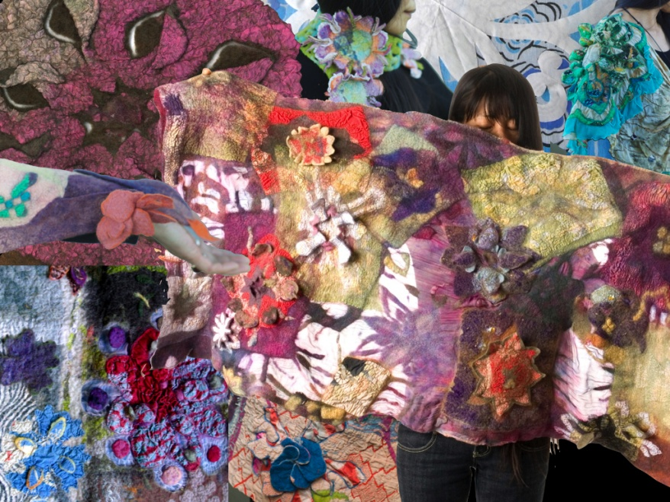
The major technique which Sachiko will teach in this 2 day workshop has evolved from her childhood playing with paper. The technique – where fabrics or pre-felts (soft felt) or pre-nuno-felts (soft felt with fabric), are folded (ori) and then cut (kiri) – is Sachiko’s attempt to adopt the ‘kirigama’ (cut paper) technique as a feltmaking method!
This technique is used for making decorative borders or various points (eg a snow flake has 6 points), usually flowers or geometric shaped cutouts (stencils). These decorative borders and cutouts are for creating imaginative imagery for surface designs, or they can be joined to construct a piece. They can also be layered or woven; and parts of some cutouts can be projected to create a tactile surface.
Sachiko developed this technique in 2009 and it has been taught in many places in Australia and the USA since then. By the way, the first and second ‘orikiri felt’ workshops were held at Blue Knob Hall Gallery in 2010, and this class will be the 4th one at the Gallery.
This class is for everyone – from beginner to advanced feltmakers or artists, including anyone who may have attended former classes. The technique will work for creating simple to complex pieces. The participants can make some sample pieces; a felt/nuno-felt piece using either all or some of the techniques which Sachiko will introduce to the class. If you are an experienced feltmaker, you may combine the technique in your own methods!
You will have a 183cm x76cm table to layout your felt. Because the time is limited, you may make a relatively easy piece from the items below. And if you would like to make a complex piece or fitted garment, you can complete it at home after the class. Sachiko will assist you in creating your desired piece according to your level of development.
Items participants may make using this technique effectively could include: garments, head-wear, ornamental accessories, blankets, throws, hangings, book covers, lampshades, vessels and more!
Date: Saturday 14th and Sunday 15th March 2015
Time: 10am – 4pm
Venue: Moore Workshop Space at Blue Knob Hall Gallery
Fee: $170 – includes a handout, plus hot drinks (tea and plunger coffee) and nibbles in the class.
It is essential to make an early booking.
Please email Sachiko at kotakaart@gmail.com
This will be a small class and the maximum number of participants will be six because of the available space.
Please send Sachiko the deposit of $85 (cheque or money order by mail) or deposit to her bank account, to reserve your place after making the booking (ask her for details when you book).
Conditions of deposit: It is non-refundable unless you or Sachiko can find another person to fill your place. The receipt will be handed to you when you pay the rest of the fee at the end of the workshop.
- The materials list will be emailed to the people enrolled in the class a month before the workshop.
- You can bring your own – or purchase First Edition’s merino wool and/or Kerry Heinzel’s hand-dyed silk (approx 183cm x76cm) from Sachiko, or Kerry Heinzel’s hand-dyed merino wool available from the Gallery.
- Feltmaking equipment can be borrowed for a reasonable cost ($5) if you would like to request it when you enrol in the class.
- Order lunch, snacks or coffee from Cafe Blue Knob or bring your own.

